**WEEK 1**

**TASK**

**Power BI**: **Microsoft Power BI** is a data visualization platform used primarily business intelligence purposes. Power BI stands for Power Business Intelligence and refers to a collection of software services, tools, and connectors that help you transform data from multiple sources into actionable insights.

**Dataset**: The dataset has 73,827 rows and 12 columns, capturing agricultural data like State_Name, District_Name, Crop_Year, Season, Crop, Area, and Production. It includes both numerical and categorical data, with some unnamed columns and missing values. The data covers various crops across different states, districts, years, and seasons.

**Steps Taken in Week 1:**

1. **Installation of Power BI:** Downloaded Power BI desktop from Microsoft Store and installed it on my laptop.
2. **Exploration of features:** Explored report view, table view and model view and DAX query view.

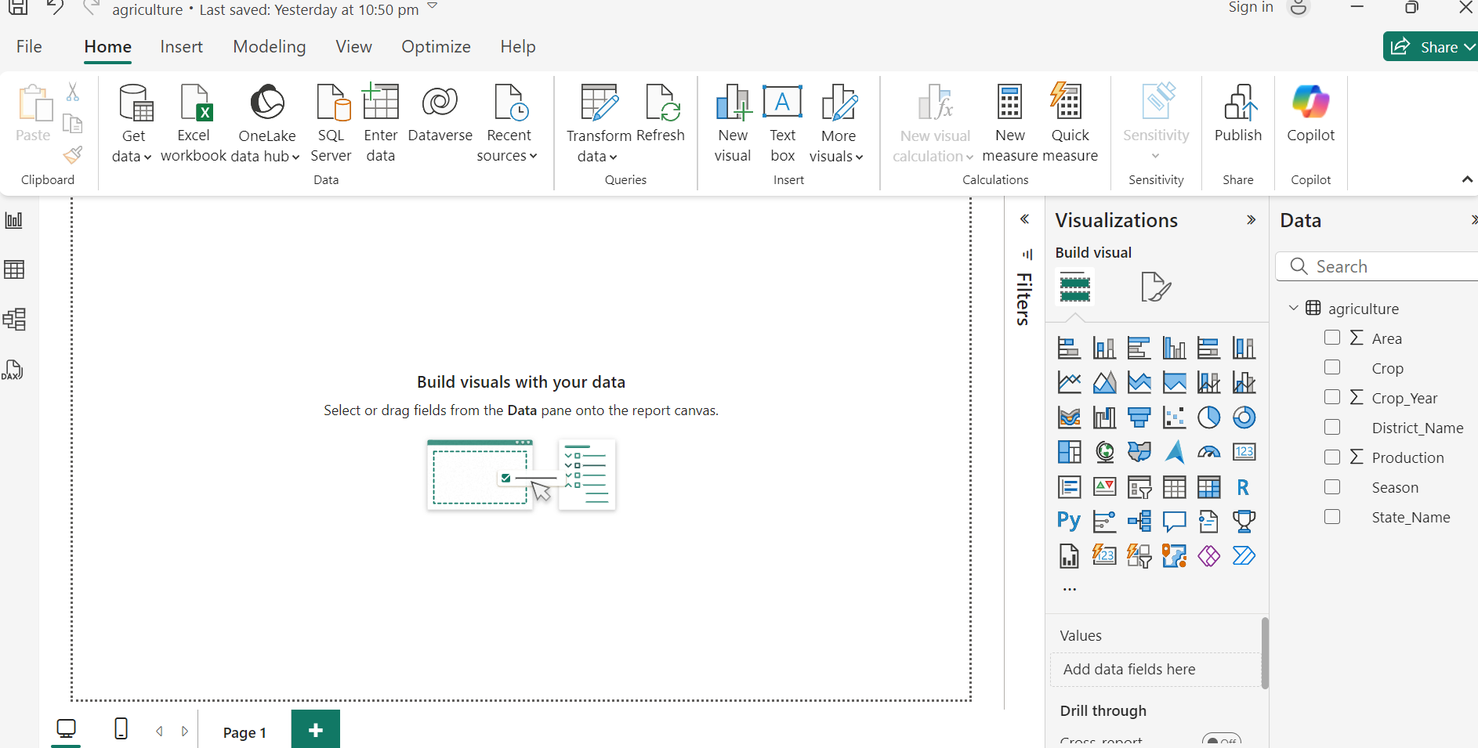

1. **ETL: Extract Transform Load process**

Extract the data by using get data option and choose Text/CSV to upload the csv file.

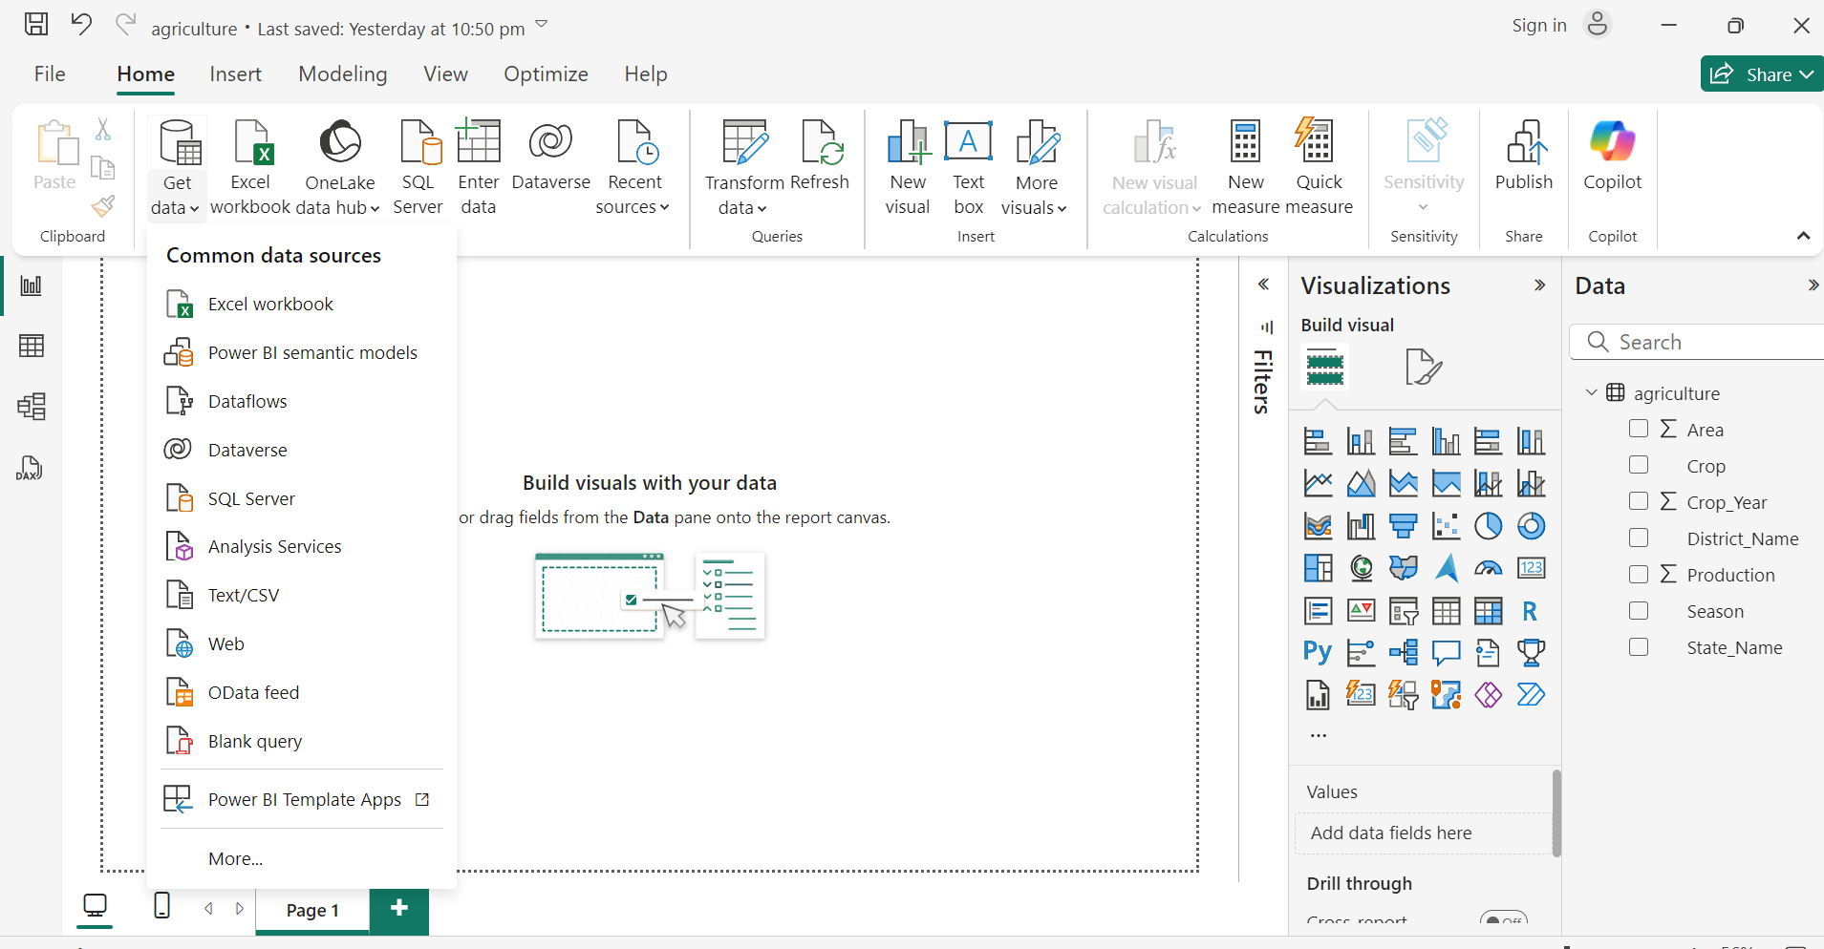

1. **Transform data:** Click the transform data option and transform the data by removing unnecessary and blank columns form the data. I removed Row_id and other blank columns which are not helpful for data visualization.

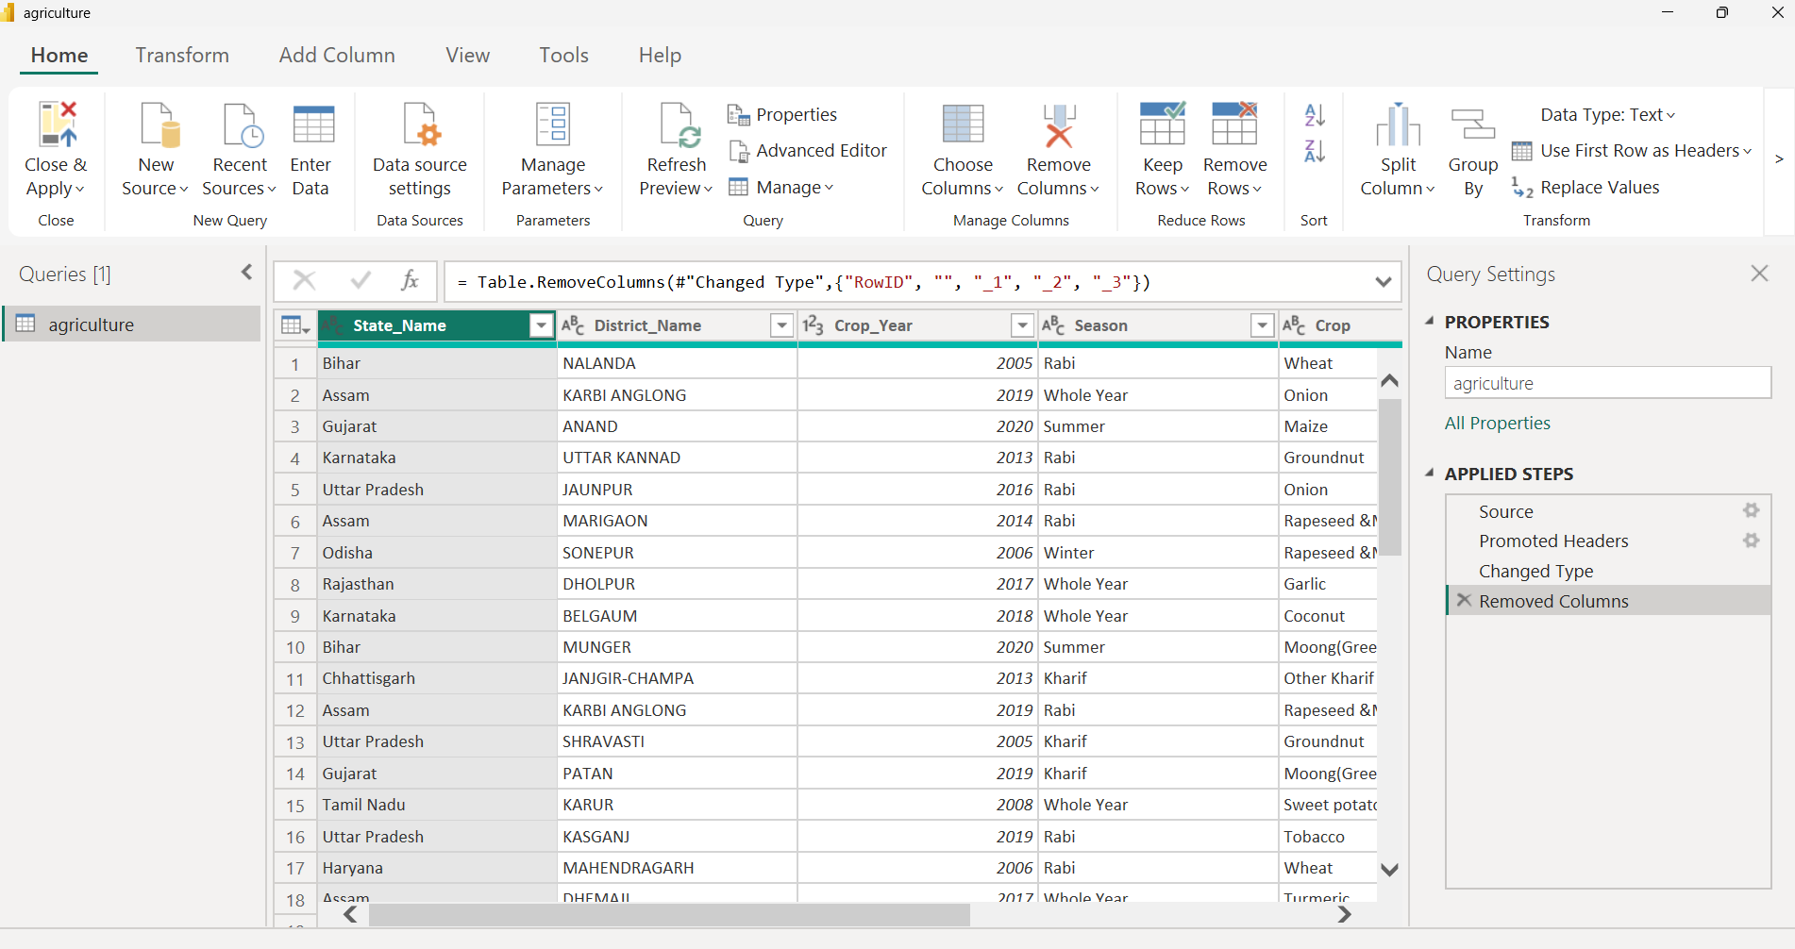

1. **Load the cleaned data for visualization:** We are cleaning the data by removing the columns which do not aid in the visualization process.

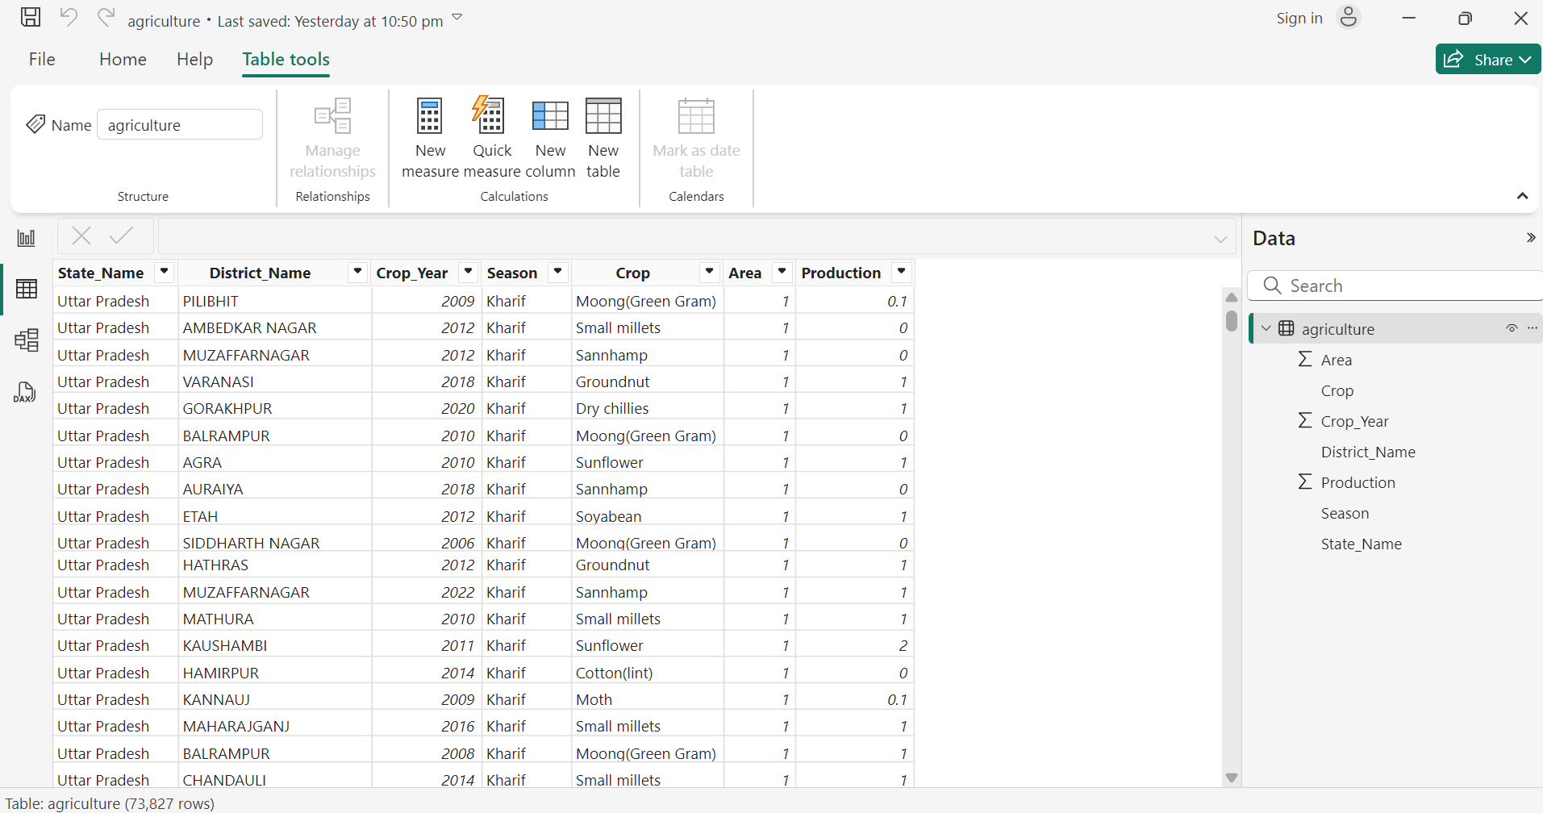

**Conclusion:** Finally, the data is cleaned and can be used in the visualization process by using ETL.